Chapter 1: First Peoples; First Farmers/ Most of History in a Single Chapter TO 4000 B.C.E.
EUROPE p. 14-15

ASIA p. 14-15
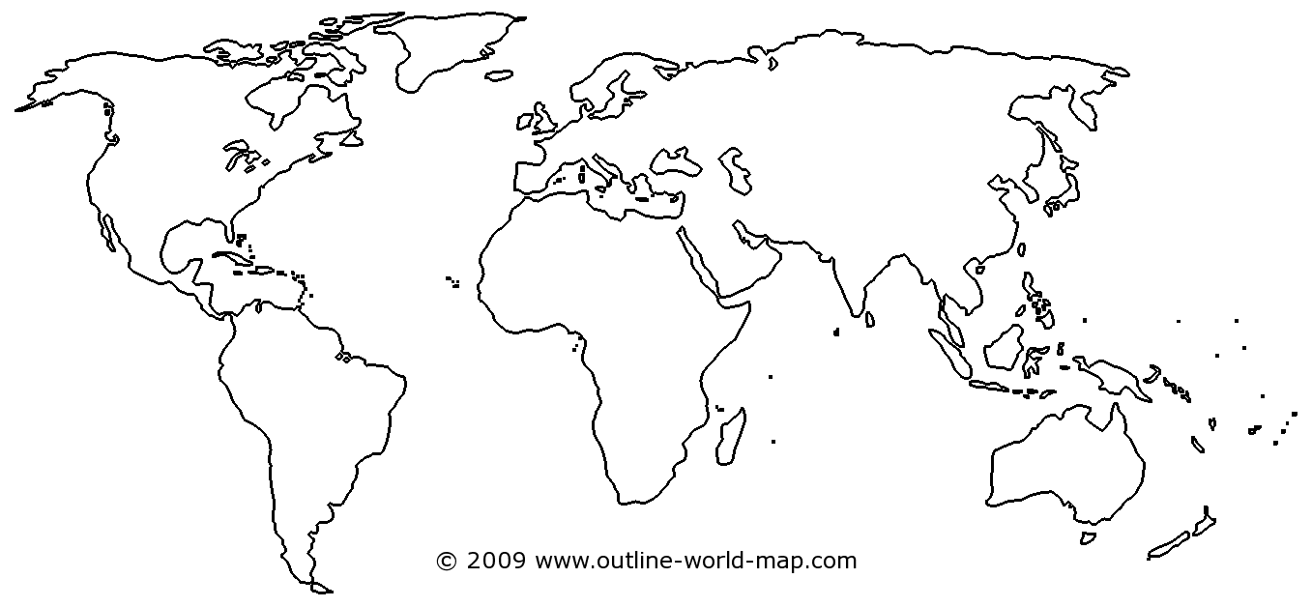
AUSTRALIA p.15-18
AFRICA p.12-14
AMERICA p. 18-19
PACIFIC p.19-20

