Chapter 2: First Civilizations Cities, States, and Unequal Societies 3500B.C.E. – 500 B.C.E.
MESOPOTAMIA/ SUMER p.62
INDUS VALLEY p.66
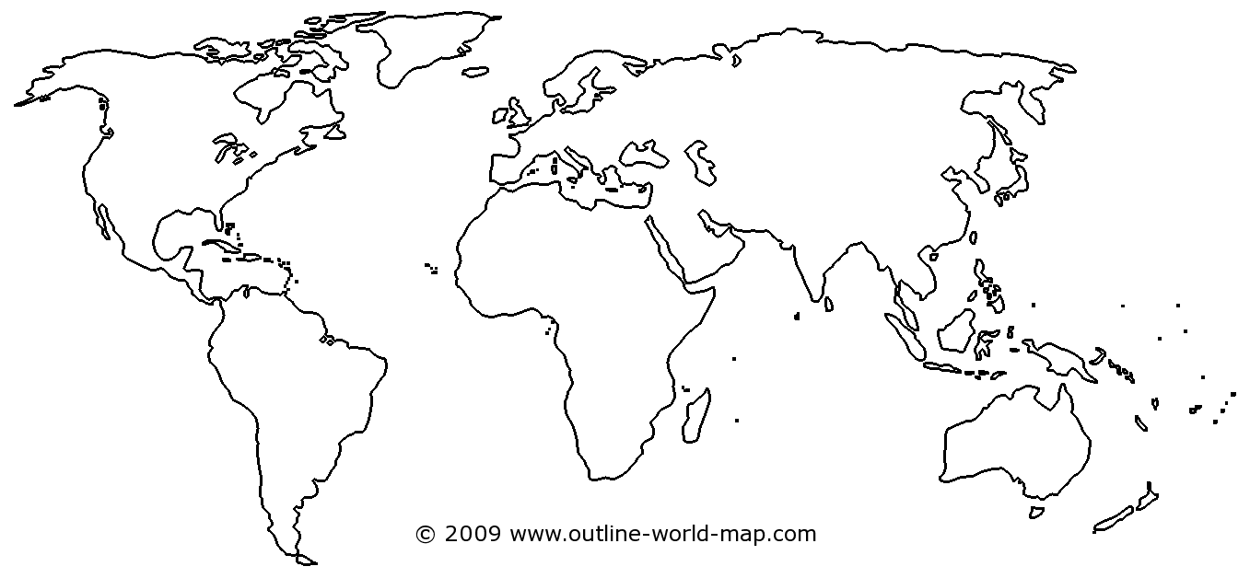
OXUS p.67
NORTE CHICO p.63-66
CHINESE CIV. SHANG DYNASTY p.67
EGYPT p.63
OLMECS p.68

