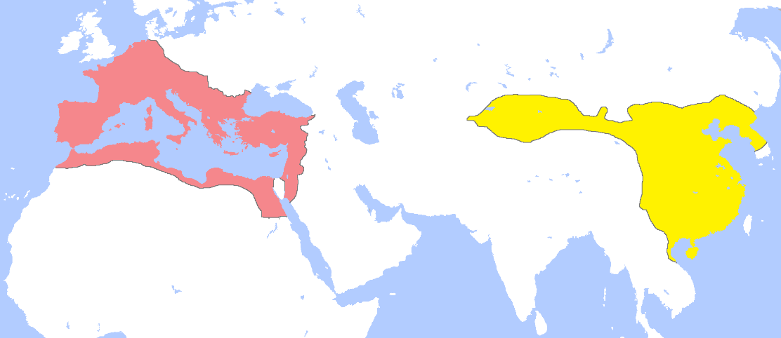

Roman Empire p. 129-133



China p.133-136



|  |  |  |
| --- | --- | --- |
|  | Roman Empire | Chinese Empire |
| Dates |  |  |
| Size |  |  |
| Social inequality |  |  |
| Epidemics |  |  |
| Invasions |  |  |
| Consequences |  |  |

Image result for 5

India p. 141-143 (Aryans, Mauryan Empire, Ashoka, Gupta Empire) (Pay attention to similarities and differences between India and Rome/China

Similarities and Differences in how Rome and China strengthened their empires. (Include: public works, legitimacy to rule, religion, cultural assimilation, writing, etc. p.136-138

Similarities in how the Roman and Chinese Empires collapsed. P.138-141