Chapter 3: State and Empire in Eurasia/North Africa 500B.C.E. – 500 C.E.

Image result for 5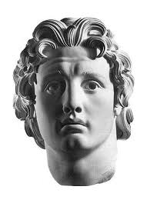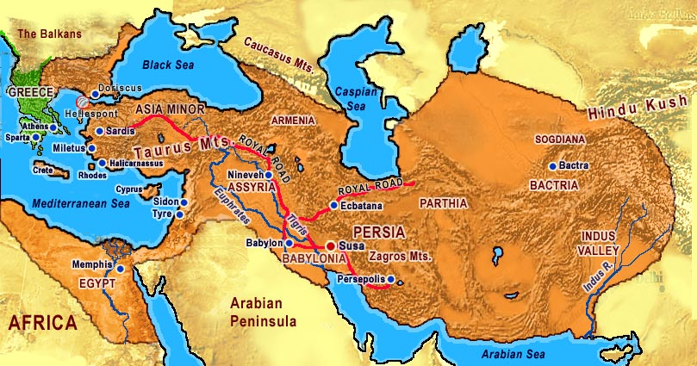

Greece p.122-125



Greco-Persian War p. 125

Persia p.120-122



Alexander the Great conquers both Greece and Persia/ Hellenistic Era p.126-129



Positive and negative consequences for Greece p. 126 

[Cite your source here.]

Positive and negative consequences for Persia p.126

[Cite your source here.]