Chapter 2: The Constitution
History behind the Constitution: (Enlightenment, John Locke, natural rights, consent of the governed, limited government, American Revolution, Declaration of Independence) (p. 26-30) Summarize the early history of US using as many of the terms listed above as possible.

The Government that failed: 1776-1787 (p. 30-32)
 | Articles of Confederation: | Constitution:
Collecting taxes
Federal courts
Rules on trade
Executive branch
Raising an army
Amending the doc.
Representation of states

Economic Problems and Shays’s Rebellion (p.33) ________________________________________________________________________________________________________________________________________________________________________________________________________________________________________________________________________________________________________________________________________________________________________
Philadelphia Convention and the making of a new Constitution (p.33-44)
Founding Fathers shared 4 common beliefs: ________________________________________________________________________________________________________________________________________________________________________________________________________________________________________________________________________________________________________________________________________________________________________

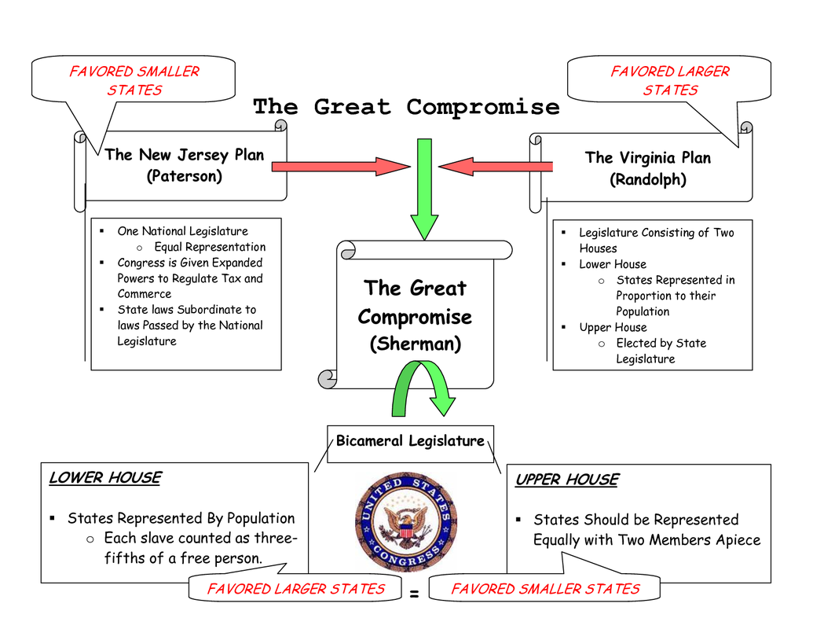

3/5 compromise: ____________________________________________________________________________________________________________________________________________________________________________________
The Madisonian System (p.40-44)
Separation of Powers: ____________________________________________________________________________________________________________________________________________________________________________________
Checks and Balances: ____________________________________________________________________________________________________________________________________________________________________________________
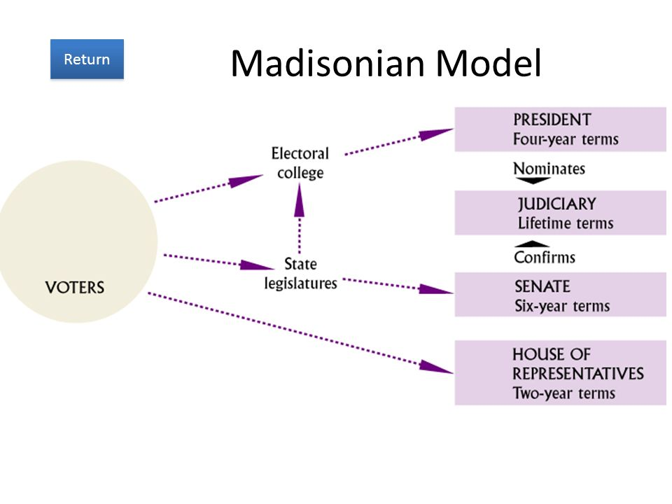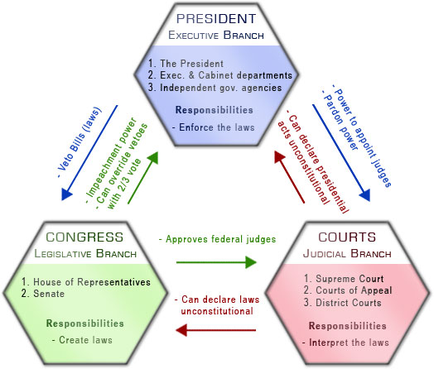
What was the Madisonian model: ____________________________________________________________________________________________________________________________________________________________________________________

Ratifying the Constitution (p. 44-46)
Definition of ratification: ______________________________________
Anti-Federalists | Federalists
Background
Government Preferred
Federalist Papers: ____________________________________________________________________________________________________________________________________________________________________________________
Bill of Rights: ____________________________________________________________________________________________________________________________________________________________________________________
Changing the Constitution (p.46-52) Take additional notes to make sense of the chart below. Take the notes around the boxes.
Marbury v. Madison: ______________________________________________________________________________________________________________________________________________________________________________________________________________________________________________________________________________
Judicial Review: ______________________________________________________________________________________________________________________________________________________________________________________________________________________________________________________________________________

Bottom Line: (p. 52-54)
The Constitution itself was not democratic.
Why???
_______________________________________________________________________________________________________________________________________________________________________________________________________________________________________________________________________
Give an example to prove that it was not democratic: ________________________________________________________________________________________________________________________________________________________________________________________________________________________________________________________________________________________________________________________________________________________________________

Over time, the Constitution has become more democratic and inclusive.
Why??? ______________________________________________________________________________________________________________________________________________________________________________________________________________________________________________________________________________
Give an example to prove that it has become more democratic and inclusive over time: ______________________________________________________________________________________________________________________________________________________________________________________________________________________________________________________________________________

