Observe the three charts below and draw conclusions about the trends identified.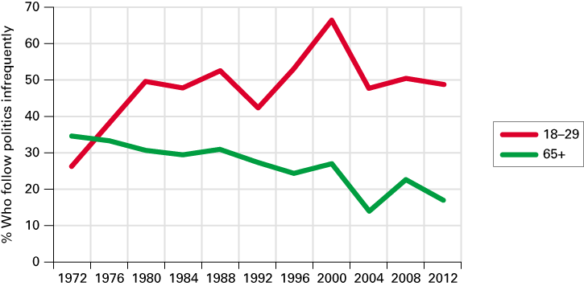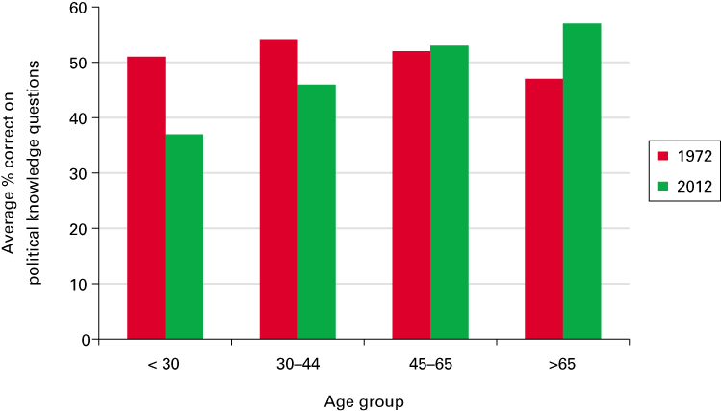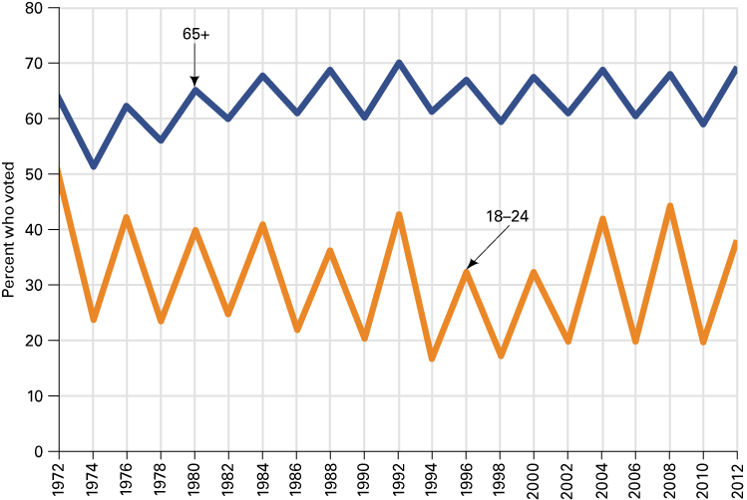
Chapter 1: Government in America

____________________________________________________________________________________________________________________________________________________________________________________________________________________________________________________________________________________________________________________________________________________________________________________________________________________________________________________________________________________
Government (1.1 Identify the key functions of government and explain why they matter) (p. 7-8)
Definition of government: ____________________________________________________________________________________________________________________________________________________________________________________
Take notes about the various functions of the government. Structure your notes as a web.

Functions of Government

Politics (1.2 Define politics in the context of domestic government) (p. 8-9)
Definition of politics: ____________________________________________________________________________________________________________________________________________________________________________________
Definition of political participation: ____________________________________________________________________________________________________________________________________________________________________________________
Definition of single-issue groups: ____________________________________________________________________________________________________________________________________________________________________________________

The Policy-making system (1.3 Assess how citizens can have an impact on public policy and how policies can impact people) (p. 9- 12)
Definition of policymaking system: ____________________________________________________________________________________________________________________________________________________________________________________
Definition of linkage institutions: ____________________________________________________________________________________________________________________________________________________________________________________
Definition of policy agenda: ____________________________________________________________________________________________________________________________________________________________________________________
Definition of policymaking institutions: __________________________________________________________________________________________
Definition of public policy: ____________________________________________________________________________________________________________________________________________________________________________________
Linkage Institutions Policymakers Policymaking institutions
Public Policy (what the policymakers who work within the various policymaking institutions chose to do about the policy agenda or the big political issue at stake
Political issue
Congress - Statues
BIG ISSUE
Policy Agenda
Political issue
President – presidential actions / executive orders
Political issue
Political issue
Courts – legal opinions
Bureaucracy

Policy Impact. Measures effectiveness and the cost associated with the public policy.

THE POLICYMAKING SYSTEM
Study the Policymaking system above and summarize it in your own words. Try to use a real life example to show how it works. __________________________________________________________________________________________________________________________________________________________________________________________________________________________________________________________________________________________________________________________________________________________________________________________________________________________________________________________________
Democracy in America (1.4: Identify the key principles of democracy and outline theories regarding how it works in practice and the challenges democracy faces today) (p.12-19)
Definition of democracy: ____________________________________________________________________________________________________________________________________________________________________________________
Equality in voting:

Criteria for democracy:

Increased complexity of issues:

Challenges to democracy:

3 Contemporary theories of American Democracy: (Take notes in the boxes)

Pluralism

Elitism

Hyperpluralism

5 elements that hold our democracy together and that we hold dear in our political system:
Liberty:
Individualism:
Laissez-faire:
Populism:
Egalitarianism:
The scope of government in America (1.5: Outline the central arguments of the debate in America over the proper scope of government) (p. 19-21)
Large government = _________________________________________________________________________
Smaller government = _______________________________________________________________________

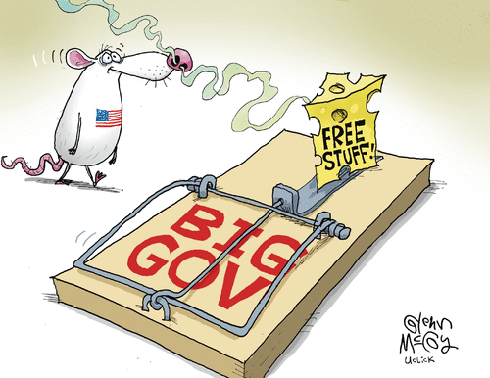
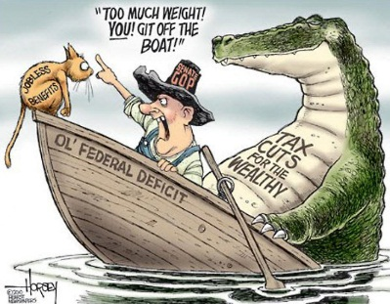
Pick 1 of the 2 cartoon and explain the message. What is the artist’s point of view on the size of the federal government? Do they support a large federal government or a smaller federal government? How do you know?
__________________________________________________________________________________________________________________________________________________________________________________________________________________________________________________________________________________________________________________________________________________________________________________________________________________________________________________________________________________________________________________________________________________________________________________________________________________________________________________________________________________________________________________________________________________________________________________________________________________________________________________________________________________________________________________________________________________________________________________________________________________________________________________________________________________________________________________________________________________________________________________________________________________________________________________________________________________________________________________________________________________________________________________________________________________________________________________________________________________________________________________________________________________________________________________________

